Journal of Dentistry, Shiraz University of Medical Sciences (JDSUMS)
Assignment of Copyright and Authorship Responsibilities

The undersigned authors hereby affirm that the manuscript entitled:
Title: Periodontitis and Neurocognitive Outcomes: Systematic Review and Meta-Analysis
Reference Number: N/A
- Is original and all statements asserted as facts are based on the author(s)’ investigation and research.
- Has not been published in any form and is not under consideration for publication elsewhere, in total or in part, except as an abstract of less than 400 words in the form of scientific presentations.
- Will not be submitted elsewhere for a period of six months from the date of submission to the Journal of Dentistry. If duplicate publication occurs, justification must be declared with appropriate permission letters.
By signing this form, the authors acknowledge that they have contributed significantly to the work and accept full responsibility for the integrity and accuracy of the data presented herein.
Upon acceptance, the author(s) assign to the journal all rights and interests in the copyright of the manuscript, including the right to reproduce, distribute, and disseminate the work electronically or in any revised form under the CC-BY 4.0 license, while the authors retain the right to use their work in future publications, presentations, or teaching.
All authors must sign: (Please mark the corresponding author)
* Corresponding author
no | Date | Name | Category (% of contribution) | Signature
1 | 17 September 2026 | Yoifah Rizka Wedarti * | Conceptualization and study design; literature search, study screening, data extraction and data curation; formal analysis and interpretation; manuscript drafting; critical review and final approval (40%) | 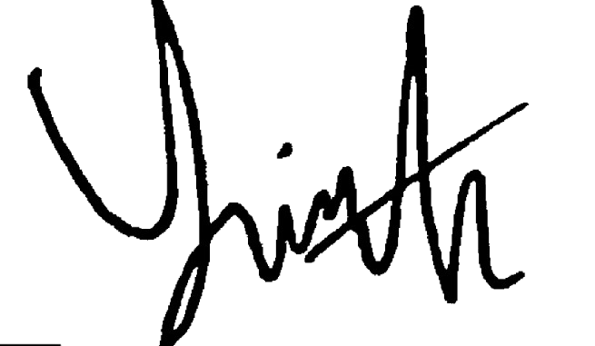
2 | 17 September 2026 | Soetjipto | Conceptualization and study design; literature search, study screening, data extraction and data curation; formal analysis and interpretation; critical review, supervision and final approval (35%) | 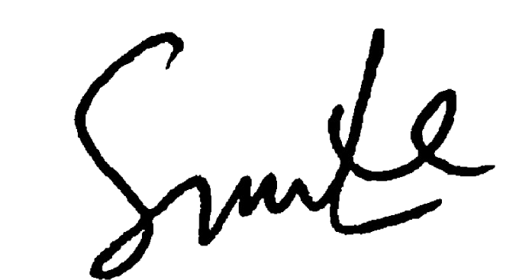
3 | 17 September 2026 | Agung Krismariono | Conceptualization and study design; literature search, study screening, data extraction and data curation; critical review, supervision and final approval (25%) | 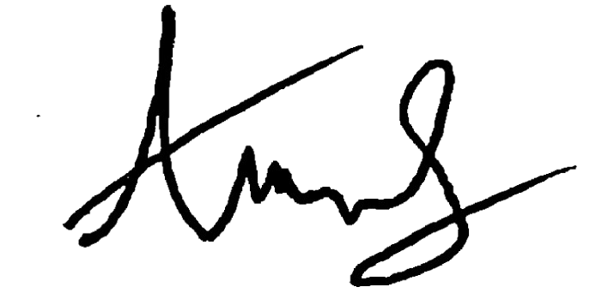

Sign by Correspondence author:

Yoifah Rizka Wedarti

